Age Friendly Community Planning Meeting
Wednesday May 20, 2015
1:15 – 2:30pm
At the Golden Museum (1302 11 Ave S, Golden)

Attendees: Tanis Brown, Kate McCarroll, Connie Barlow, Amy Angheluta, Irene Gray, Linda Balas, Monica De, Katherine Hamilton, Steph Braul, Doreen Kelley, Joy Orr, Mickey Balas, Ann Younger, Ken Thompson, Mike Symons, Jim deBolebec, Denise English, Darren Dusevic, Chris Hambruch, Ron Oszust, Leslie Adams, Ryan Watmough
Chair: Denise English
Minutes: Ryan Watmough

Agenda

A. Call to Order: 1:15pm

B. Review and Approval of Past Minutes (Apr 2, 2015; circulated)

C. Updates on items from last meeting
Ryan Watmough: Officially recognizing Golden as an Age Friendly Community – Still waiting to hear back from the Ministry.

Ryan Watmough: Update on CBT Community Initiative Program grant application

    - Our project to hire an AFC coordinator was selected to receive $20,934.38
    - Hired an Age Friendly Community Coordinator – a sub-committee (Monica, Connie and Mickey) met and reviewed applications
    - GCRS is the employer, but the Age Friendly Committee will have to be active with the AFC position.
    - Started May 8, ending Jan 8, 2016. 15 hours/week.
    - Goals: To help execute the Age Friendly Community Plan (AFCP) and other priorities as they are identified, find funding to execute and monitor the AFCP.

D. Review of Action Plan – updated in April 2015 (circulated)

E. Informal update on Sidewalks: past, present & future - Chris Cochran, Town of Golden

Figures from Golden’s AFCP – July 2014:
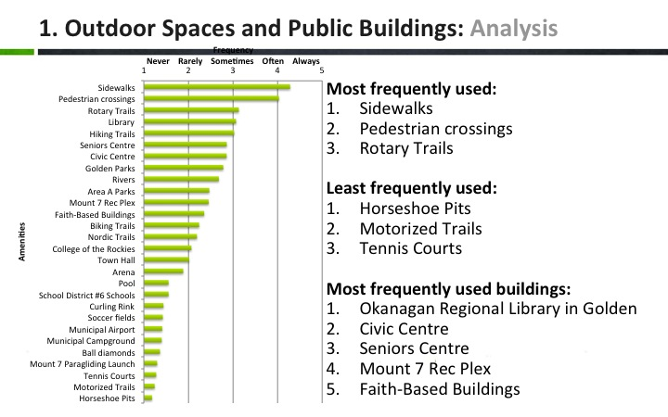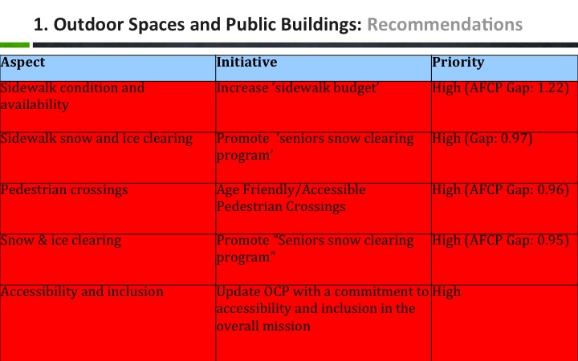

  - Have a capital & maintenance budget for each year. Capital is large; and maintenance is fairly steady.
  - Also have access to other funding (RMI, gas tax, etc.).
  - Council has requested options for potential connectivity for sidewalks (closing gaps).
  - Another strategic priority that came out of the planning process was a “Trails Priority Plan” which will identify priorities, jurisdictional issues, etc.
  - Sidewalk replacement cost is $400/m. Town of Golden will be replacing sidewalk on 10th/near Overwaitea; Durand Manor; Alexander Drive to complete the sidewalk infrastructure over the next several years (removing and renewing).
  - Has discussed with the ToG team the ‘priority corridor system’ in the AFCP and will help make it a priority in clearing snow. 9th St, between Seniors Centre and downtown core is a priority.
  - Hearing from young mothers with strollers, too, Chris Cochrane is hoping to install a ‘zebra crosswalk’ at the Seniors Centre.
  - Joy and Irene expressed the need for continued efforts in maintenance and education on usage. Mickey is concerned with about yellow spray paint on sidewalk cracks.
  - Ron asked Chris Cochrane to clarify what would be missed if other areas are made “priority.” Chris responded that if they focus on the ‘priority corridor system,’ then other residential sidewalks will be bumped down the priority list.
  - Golden Hill signage will likely remain at “use at your own risk.”
  - The gravel section just south of the KH Pedestrian Bridge can be addressed once ownership issues are sorted out.
  - Katherine Hamilton mentioned that CBT could be a small partner (30%) in trail improvement projects.

F. Golden Seniors Centre Society – update from Irene Gray, President
  - The Seniors Centre has 140-150 members
  - Anyone can be a member for $20/year
  - Anyone can rent the space
  - Individuals can come 2x for free before becoming a member
  - Recognize the utilization challenge; in demand for funerals, weddings, events
  - Trying to get more people in there
  - Soup Day is this Friday, $6
  - Sat. May 30th is a Tea & Bake Sale, $5
  - They are trying to put on an Art & Craft display of their members’ work
  - There is an interest to have some AFCP meetings at the Centre. Denise English & Irene Gray are going to discuss this further.
  - Tanis mentioned that getting Durand Manor residents to the Seniors Centre has been difficult because of transportation. Irene stated that the people that want or need to use it cannot get there.

G. Elder Abuse Program - Sandra Skappak from Victim Services will be dealing with the Elder Abuse program in the fall

H. Discussion regarding Durand Manor
  - Renovations – Mel Myers will forward information about a Ministry of Health funding stream that is continuous – no deadline. $6M available to fund 5-year programs.
Interior Health designer is coming in the fall to make designs and construction will start in the spring, so community involvement should happen before this. Other suggestions regarding Durand Manor: do a feasibility study to see what improvements should be made. Include BC Housing as a partner because they partnered with Mountain View Assisted Living.
Katherine Hamilton explained that CBT cannot help fund either options as it is a public (IH) facility – unless it becomes a ‘top community priority’ (like the yet-to-be-built Golden Early Learning and Care Centre at APES).
Creating new long-term residential units is priority #2 and rated with High Importance in the Age Friendly Community Plan. The short-term plan is to focus on beautification at Durand.
At this time there is no formal appetite to form a sub-committee to work on this issue.
  - Transportation - Durand residents need transportation to get out to community events. Their social health is decreasing because of this.
Lindsay Cox would like to donate a van, but there is limited space and there are still many prohibitive costs that don’t make it feasible.
Ron mentioned that the former KH Transit was the highest cost/rider in BC before it was cancelled.
Joy suggested creating a Drive Share. Tanis said that because of the insurance policy, IH can only use the BC Transit bus 6 times per year, but this can still be an option.
The question was asked, “Can this need compliment a broader community need?”
Denise suggested that ‘transportation’ be the focus of a committee if we knew all the facts (find out where is it working, and how to emulate it).
Colleen, Tanis, Ron & Jim will form a committee and report back at the next AFCP.
I. Additional Items
Town of Golden Rec & Leisure update
Jordan forwarded an email that stated,
“The new ‘membership’ / drop in program platform that we are launching at the pool (for this summer) and the Rec Plex / Arena
- Would like to update people that we are trying to take a new approach at facilitating community / drop in programing at our facilities
- Update on existing programs (summer Aquafit & winter walking)”

Seniors SI – “Reducing Social Isolation for Seniors”
- Please review the info and webinar on http://www.innoweave.ca/en/about/seniors-si
- The application process opens May 29 and closes mid-July.
- The program offers grants from $150-750K spread over 3yrs, which will include multiple projects per community. Will need to demonstrate social inclusion impact on a population (entire population or sub-set).
- Start looking at Golden’s AFCP findings related to priorities #4) Social Participation and #5) Respect & Social Inclusion to show a demonstrated need.
If you are interested, contact Ryan, who will form a sub-committee to pull together an application.
Frustrations that Doctors are showing relating to Interprovincial Barriers to Healthcare
- Mickey raised this issue.
- Kate recapped that the Chief of Staff had written a letter to the Editor of the Golden Star; along with many cases of trying to find healthcare services outside of Golden.
Mickey asked is the Town or any other groups taking any action?
- Ron explained that IH is trying another strategy by increasing the capacity in Cranbrook. He also mentioned that healthcare is always a topic of government.
- Chris Hambruch is on the Kootenay Regional Health Board, which looks after building hospital infrastructure. Chris believes that we are very well-served by physicians in Golden. Chris also outlined the high ‘Emergency Department’ demand in Invermere is from Albertans.
- Joy explained that the Province of BC is very slow to pay, which doesn’t help with BC patients that are seeking care in Alberta.
- Kate explained that local physicians are always trying to upgrade to provide more services here. There is also a committee of physicians looking specifically at transportation issues.
- Tanis encouraged everyone to realize what services we do have in such a small, rural community.
Mickey will form a committee to explore this issue further.
J. Next Meeting – Wednesday June 17th, 3:00pm – 4:15pm; Seniors Centre
K. Adjournment – 2:41pm
Anyone interested in helping to make Golden an Age Friendly community is welcome to come to the meetings. Tell your friends, family & colleagues.
Ryan Watmough, AFCP Coordinator
250-344-8610
nonprofits.gcrs@gmail.com
www.goldenloom.ca/age-friendly.html

